Exp1:-
Title of the program:-
Write a program to compute the factorial of a number. Write the flowchart of the program.
Flowchart:-

Start

int n,i=1,product=1
Take the value of n
product=product * i
if i<5
print product
End
No
Yes
i=I + 1

Program instruction:-
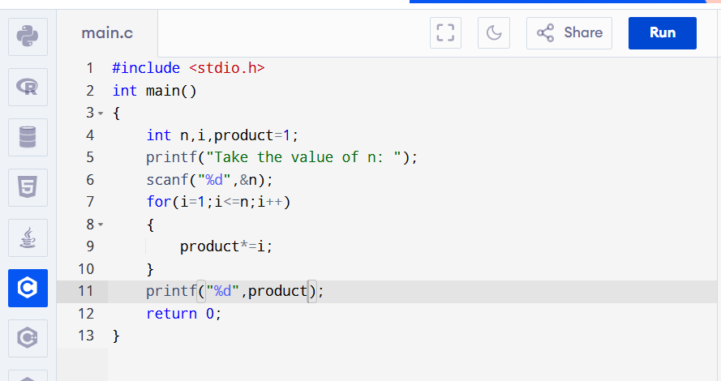
Output:-

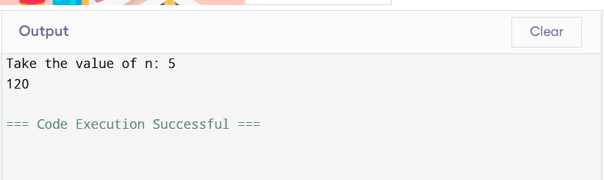
Exp2:-
Title of the program:-
Write a program to print the Fibonacci series of length 10. Write the flowchart of the program.
Flowchart:-
Start

int n, a=1,b=1,sum,i=0
Take the value of n
sum=a+b
if
i<n
a=b
End
No
Yes
print a
b=sum

Program instruction:-
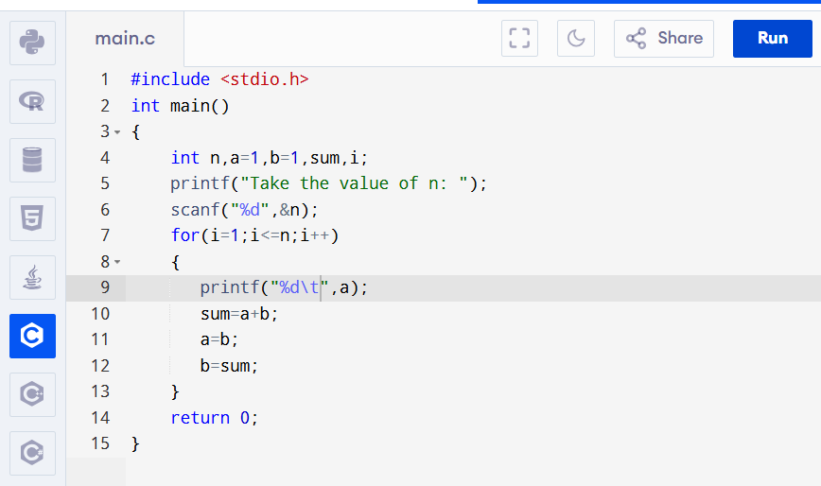
Output:-
